Chapter 4
DESIGN AND methodology
This chapter will go over the procedure, techniques, and tools, among other things. Documentation aids were used in this study. It includes several diagrams, figures, and tables to help explain the methodology used visually.
Project Concept
A project concept is a statement that gives a program or project its direction, depth and meaning.
Include your system architecture here.

Figure 4.1 System Architecture of the Proposed System
Analysis and Design
Analysis emphasizes an investigation of the problem and requirements, rather than a solution. For example, if a new computerized library information system is desired, how will it be used? “Analysis” is a broad term, best qualified, as in requirements analysis (an investigation of the requirements) or object analysis (an investigation of the domain objects). Design emphasizes a conceptual solution that fulfills the requirements, rather than its implementation. For example, a description of a database schema and software objects. Ultimately, designs can be implemented. As with analysis, the term is best qualified, as in object design or database design.
Analysis and design have been summarized in the phase do ... and to further explain this, the UML modelling tool is recommended.
In the Unified Modeling Language (UML), a use case diagram can summarize the details of your system's users (also known as actors) and their interactions with the system. To build one, you'll use a set of specialized symbols and connectors. An effective use case diagram can help your team discuss and represent scenarios in which your system or application interacts with people, organizations, or external systems. Goals that your system or application helps those entities (known as actors) achieve and the scope of your system. Include your Use Case Diagram here

Figure 4.2 Use Case Diagram of the Proposed System
Provide a discussion of your use case diagram
UML Sequence Diagrams are interaction diagrams that detail how operations are carried out. They capture the interaction between objects in the context of a collaboration. Sequence Diagrams are time focus and they show the order of the interaction visually by using the vertical axis of the diagram to represent time what messages are sent and when. Sequence Diagrams captures the interaction that takes place in a collaboration that either realizes a use case or an operation (instance diagrams or generic diagrams) and high-level interactions between user of the system and the system, between the system and other systems, or between subsystems (sometimes known as system sequence diagrams). Include your Sequence Diagram here.

Figure 4.3 Sequence Diagram of the Proposed System
Provide a discussion of your sequence diagram.
Class diagrams are one of the most useful types of diagrams in UML as they clearly map out the structure of a particular system by modeling its classes, attributes, operations, and relationships between objects. Include your class diagram here.

Figure 4.4 Class Diagram of the Proposed System
Provide a discussion of your class diagram.

Development Model
In the design and development of the proposed system, the researcher will be using the <<state your project methodology>>. Discuss the reason of chosing this methodology. Provide concrete statements how this methodology will help in the success and development of the study.
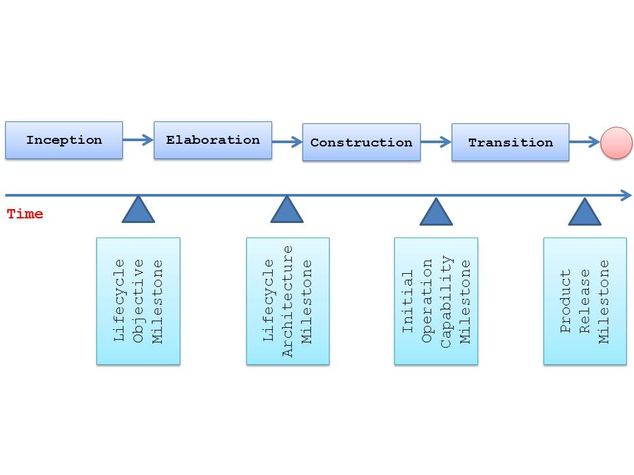
Figure 4.5 Rational Unified Process Methodology (Sample Only)
The following are the phases of <<methodology>>:
<<Phase 1>>. <<Write the conceptual definition followed by the operational definition.>>
<<Phase 2>>. <<Write the conceptual definition followed by the operational definition.>>
...
<<Last Phase>>. <<Write the conceptual definition followed by the operational definition.>>

Development Approach
A method used to create and evolve the product, service, or result during the project life cycle, such as a predictive, iterative, incremental, adaptive, or hybrid method. (In our subject it is recommended to used iterative type of methodology)
Software Development Tools
A programming tool is any software program or utility that helps software developers or programmers create, edit, debug, maintain, and/or perform any programming or development-related task. A software development tool is another name for a programming tool.
Discuss the benefits of the chosen programming language and database management system.
Schedule and Timeline
Timeline is a synonym of schedule. Timeline is a graphical representation of a chronological sequence of events while schedule is a slip of paper that presents a short note.
Discuss the schedule and Timeline using a Gantt chart.

Table 4.1
Gantt Chart
ACTIVITIES | MONTHS |  |  |  |  |  | OUTPUT(S)
ACTIVITIES | 1 | 2 | 3 | 4 | 5 | 6 | OUTPUT(S)
Requirements Planning  (Interview, Survey, Document Analysis) |  |  |  |  |  |  | Data Bank (DOLE, TESDA, Provincial Government of Sorsogon, Municipal LGU’s, PESO, Labor Groups)
User Design  (Brainstorming and Design phase – UML modeling) |  |  |  |  |  |  | UML Models (Class, use case and deployment diagrams)
Construction  (web development using HTML, PHP, CSS, JavaScript, and Bootstrap; Database Management System using MySQL; GIS mapping) |  |  |  |  |  |  | Website (Displaced Workers Information Management System With GIS Mapping)
Cutover  (Implementation, Deployment and Evaluation of the developed system) |  |  |  |  |  |  | Launching of Website (Deployment Online)

Discuss your timeline and schedule, as well as how you intend to ensure the study's completion.
Responsibilities
Provide a discussion of the assignment of task.
Project Leader. <<Who is the group's designated project leader? Discuss the project manager's role. >>
System Analyst. <<Who is the group's designated system analyst? Discuss the system analyst’s role. >>
Software Engineer. <<Who is the group's designated software engineer? Discuss the software engineer’s role. >>
Technical Writer. <<Who is the group's designated technical writer? Discuss the technical writer’s role. >>
Budget and Cost Management
Cost management is the process of estimating, allocating, and controlling project costs. The cost management process allows a business to predict future expenses to reduce the chances of budget overrun. Projected costs are calculated during the planning phase of a project and must be approved before work begins.
As the project plan is executed, expenses are documented and tracked, so things stay within the cost management plan. Once the project is completed, predicted costs and actual costs are compared, providing benchmarks for future cost management plans and project budgets.
Include budgetary requirements and focus more on the needed hardware and software of the system.

Budgetary Requirements
ACTIVITIES | DURATION MONTHS |  |  |  |  |  |  |  |  |  |  |  | TOTAL
ACTIVITIES | Q1 |  |  | Q2 |  |  | Q3 |  |  | Q4 |  |  | TOTAL
ACTIVITIES | 1 | 2 | 3 | 4 | 5 | 6 | 7 | 8 | 9 | 10 | 11 | 12 | TOTAL
- Equipment
- Maintenance and Other Operating Expenses
- Travelling Expenses
- Supplies and materials
- Representation expenses
- Others
Total Budgetary Requirements

Verification and Validation
Verification is a process of determining if the software is designed and developed as per the specified requirements.
Validation is the process of checking if the software (end product) has met the client’s true needs and expectations.
Include your evaluation tool here.
Testing
Project Testing Phase means a group of activities designated for investigating and examining progress of a given project to provide stakeholders with information about actual levels of performance and quality of the project. It is an attempt to get an independent view of the project to allow stakeholders to evaluate and understand potential risks of project failure or mismatch.
The purpose of the testing phase is to evaluate and test declared requirements, features, and expectations regarding the project prior to its delivery in order to ensure the project matches initial requirements stated in specification documents.

